BCIS-466
Wine Quality Prediction
Project for BCIS-466 By Sebastian Evans
Sebastian Evans
5-3-2026

Background
I chose this dataset for this project because I drink wine quite frequently. I took a wine tasting course here at NMSU and ever sense then I’ve grown to appreciate wine and its many types. I hope to give some insight on how the wine quality is rated and what factors play into rating wine at least based on the data provided.

Data Overview
To give a brief overview of the data is sourced from the UC Irvine Machine Learning Repository The set it was designed in a way to be used for classification or regression this of course made the data easier to use for this project so that was an added bonus for using it. The data also takes two data sets, one for red wine and one for white wine both are combined leading there to be 6497 total samples to be used all together. The data has 11 different features that have some effect on a wine’s determined quality.
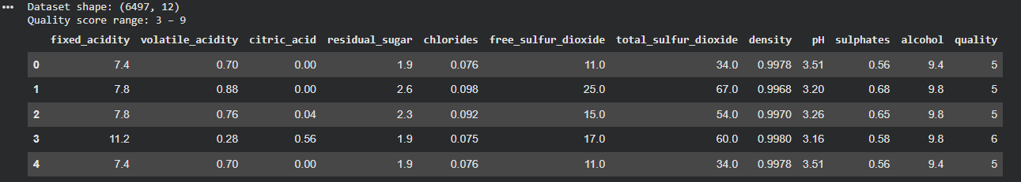

EDA
The overall point of performing Exploratory Data Analysis on this data set is to find correlations, find out if there are any imbalances among the classes and guide preprocessing decisions. All observations have no missing value, so imputation was not necessary.

Data distribution
Quality ranged from 3 to 9 with most falling between the 5 to 6 range. Because of this quality scores were separated between high and low scores with high being anything greater than or equal to 6 this separated the data into 2,384 low quality scores which is (36.7%) and 4,113 High quality scores or (63.3%).
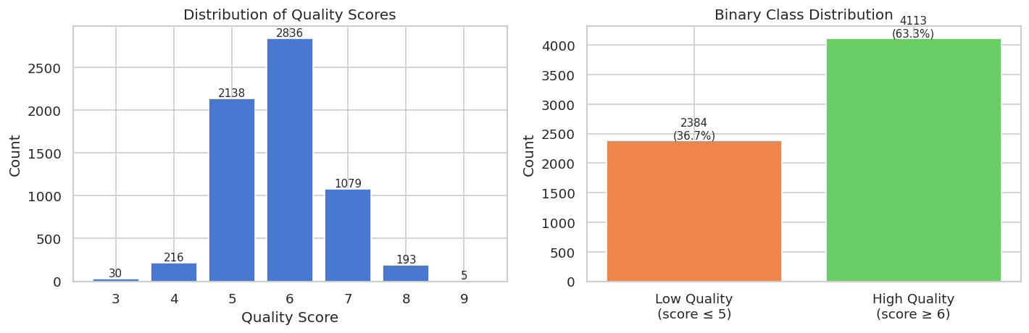
Figure 1. The left represents the raw scores while the right represents the scores separated into High and Low quality

Feature Distributions and Correlation
The 11 features Distribution vary in shapes, some show a form being right skewed those being Residual sugar, Volatile acidity, chlorides, Free sulfur oxides and Total sulfur oxides. The features closest to being considered normally distributed being Fixed acidity, pH, and sulphates.
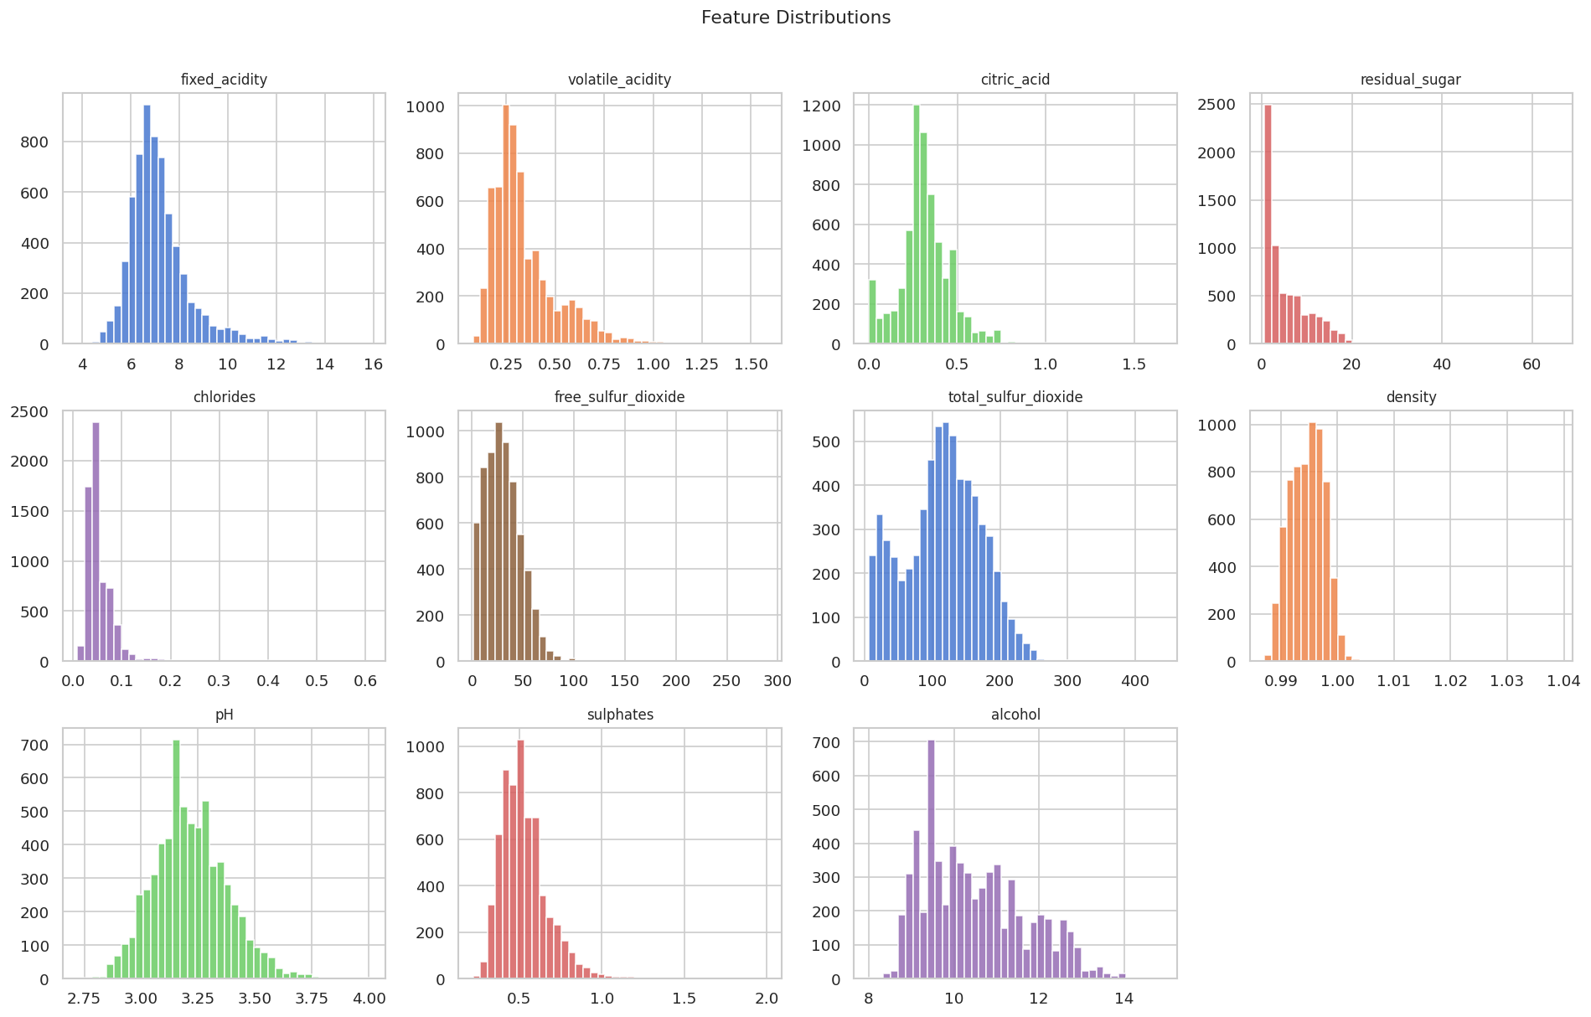
Figure 2 This Image show all of the distribution charts for the 11 features used in the data set.
A Correlation heatmap shows alcohol had the strongest positive correlation at (0.44) while volatile acidity had the most negative correlation at (-0.31).
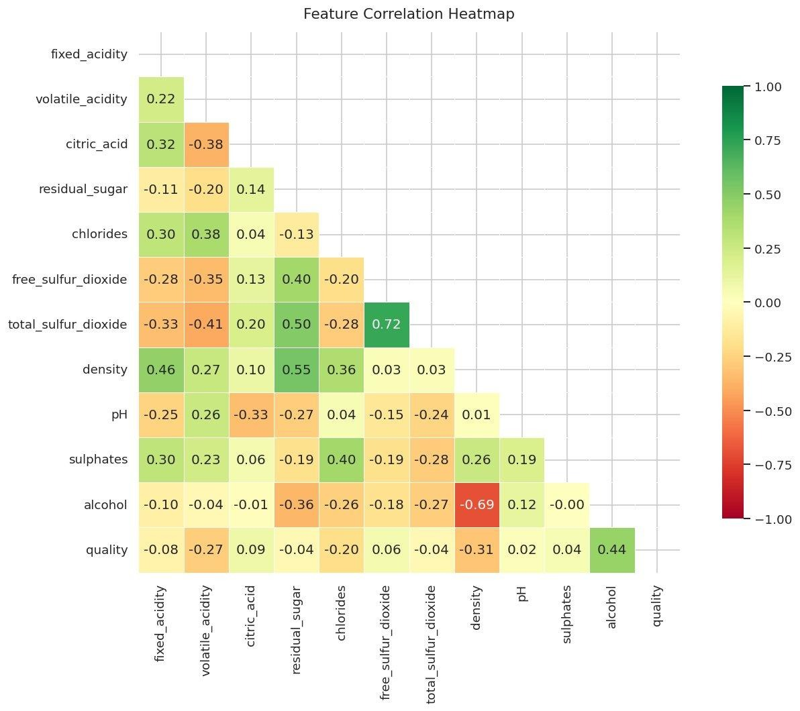
Figure 3 this Heatmap shows how much certain features correlate to each other red represents the weakest and green represents the strongest.
Boxplots were then used to compare features between quality classes, this confirmed that alcohol and volatile acidity showed the most visual separation between classes.
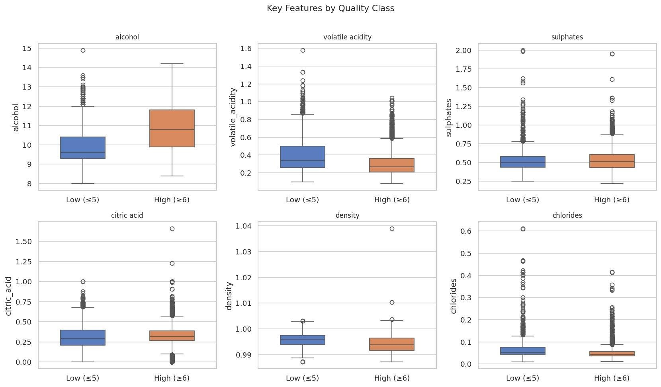
Figure 4 The box plots allow for easy visual way to determine separation between classes.

Methodology
The first step in handling the data was preprocessing it to a more useable form first it was first separated into a binary target variable as discussed in the section above. It was then stratified into an 80/20 train/test split, leaving 5,197 training samples and 1,300 test samples. Finaly all 11 features were standardized to prevent data leakage.
Three models were then chosen. Logistic regression acted as a baseline as it assumes a linear relationship between the features. Random Forest was used to look at nonlinear relationships and view feature importance score. Gradient boosting was used as it builds trees sequentially and corrects the errors of the previous one. After testing these three models random forest performed the best out of the three, so it was then tuned to increase its performance.

Results
The results of the four models are provided in the table below. Since both Random Forest models outperform the logistic regression model it can then be determined than a nonlinear relationship is important.
Model | Accuracy | ROC-AUC | CV Mean | F1 (High)
Logistic Regression | 73.4% | 0.805 | 74.1% | 0.80
Random Forest | 84.3% | 0.905 | 81.9% | 0.89
Random Forest (tuned) | 84.3% | 0.905 | 82.0% | 0.89
Gradient Boosting | 80.6% | 0.868 | 78.9% | 0.85

Confusion matrices and ROC curves are used to visually show the accuracy of each model.
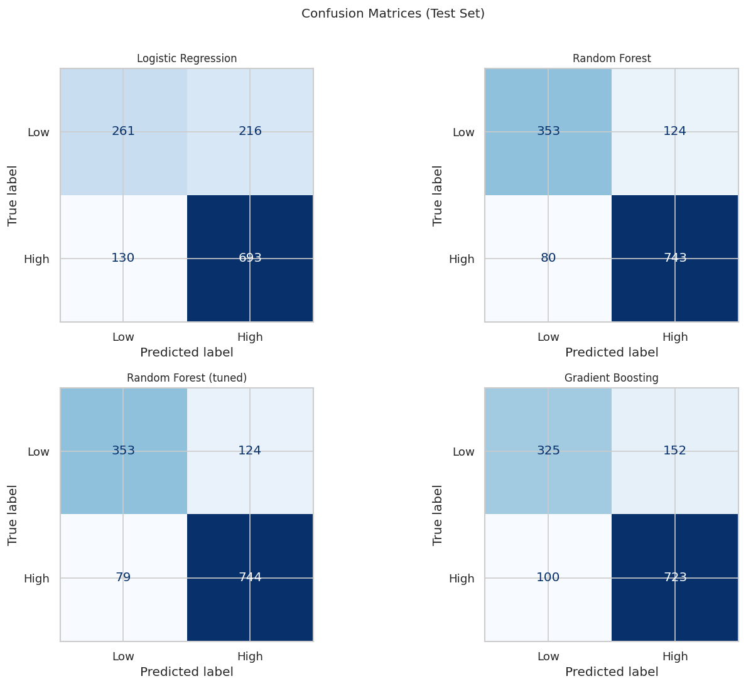
Figure 5 theses matrices are one way of showing the accuracy of the models
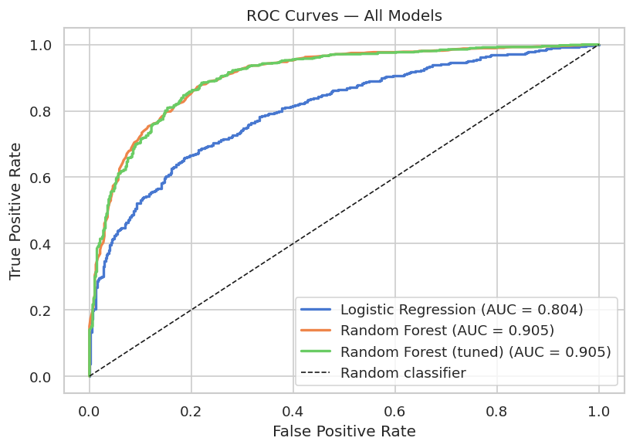
Figure 6 The ROC curve is another way of showing the accuracy of all the models.

Since the Random Forrest model performed the best that meant we could take advantage of its ability to show which features were the most important in the model. In this case the top 5 Features where alcohol (0.161), volatile_ acidity (0.116), density (0.103), total sulfur dioxide (0.083), and Chlorides (0.082)
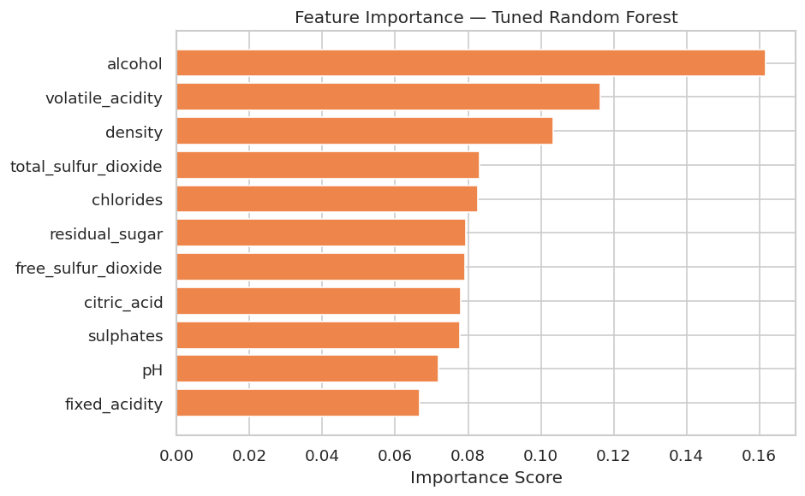
Figure 7 Using the Tuned Random Forests Importance scores we are able to create a graph showcasing which Features had the highest scores.
After all of this a learning curve is then used to show how accurate the tuned version of the Random Forrest model is.
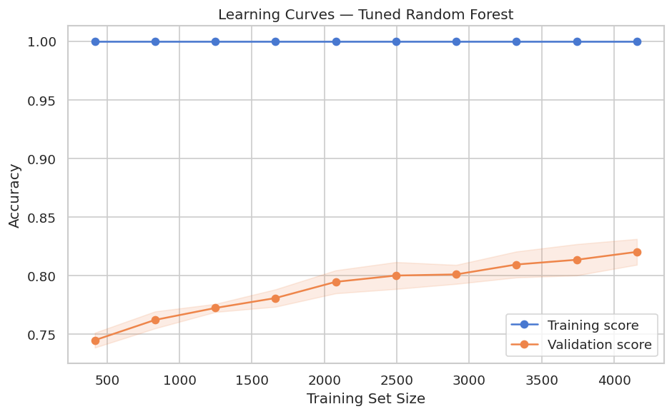
Figure 8 This is the Learning Curve Chart it is used to show accuracy. The shading represents variance less shading is more stable.

Conclusion
The tuned version of the random forest model achieved an 84.3% score on test accuracy and had an area under curve score of 90% this outperformed the other 2 models quite significantly and alcohol content and volatile acidity are the dominant predictors.
Of course, there are some limitations the first being that the quality labels in general come from the subjective opinions of wine experts. The second issue is that data only touches on the chemical nature of the wines but nothing on how grapes are grown and processed. And the final issue is that since the data set provided combines red and white wines, we don’t get a more accurate model that would account for the taste differences of the two types of wine. Ideally with more data and time to divide separate it into at minimum red and white wines we could turn this model into a tool used to predict the quality of wine in real time.

Data set source
Dua, D., & Graff, C. (2019). UCI Machine Learning Repository. University of California, Irvine. https://archive.ics.uci.edu/dataset/186/wine+quality

